Devadarshini J

192124092

Lab Manual Day 1

Exercise:

1.Write The Commands To Perform Basic Arithmetic In R.

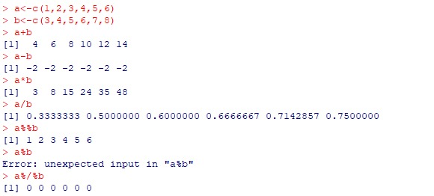

2. Display a String on R Console.



3. Declare Variables In R And Also Write The Commands For Retrieving The Value Of The Stored Variables In R Console.



4. Write R script to calculate the area of Rectangle.

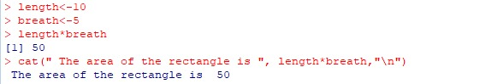

5.Write Commands In R Console To Determine The Type Of Variable



6.Enumerate The Process To Check Whether A Given Input Is Numeric , Integer , Double, Complex in R.



7. Illustration of Vector Arithmetic.



8. Write an R Program to Take Input From User.

Input name as “Jack” and age as 17.

The program should display the output as

“Hai , Jack next year you will be 18 years old”

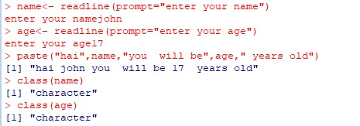

Exercise:

1) Perform Matrix Addition & Subtraction in R

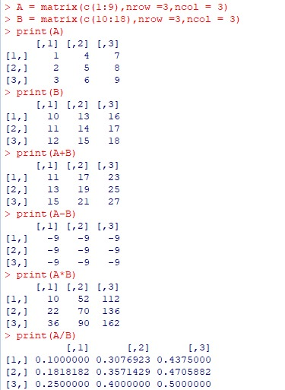

2) Perform Scalar multiplication and matrix multiplication in R



3) Find Transpose of matrix in R.

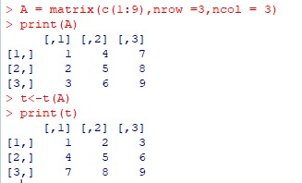

4) Perform the operation of combining matrices in R using cbind() and rbind() functions.

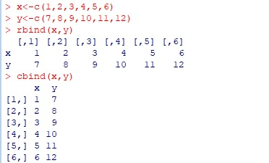

5) Deconstruct a matrix in R

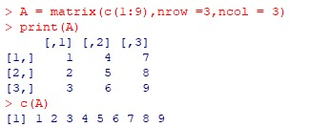

6) Perform array manipulation in R .

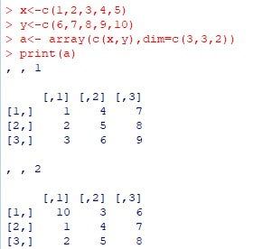

7) Perform calculations across array elements in an array using the apply() function.

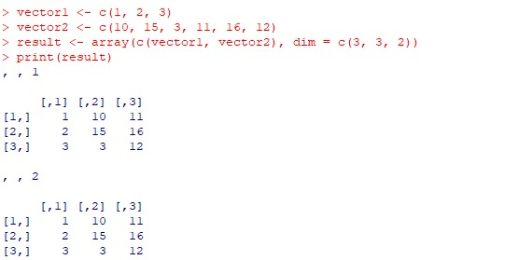

8) Demonstrate Factor data structure in R.

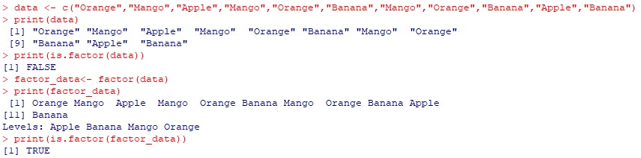

9) Create a data frame and print the structure of the data frame in R.

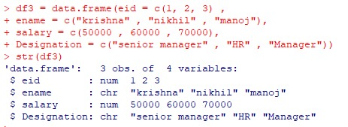

10) Demonstrate the creation of S3 class in R.

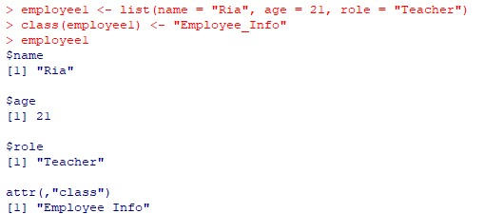

11) Demonstrate the creation of S4 class in R.

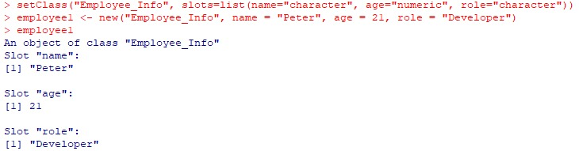

12) Demonstrate the creation of Reference class in R by defining a class called students with fields – Name, Age , GPA. Also illustrate how the fields of the object can be accessed using the $ operator. Modify the Name field by reassigning the name to Paul.

